GDB staff has carefully researched the toys in the list below; these are the only toys that may be accessed by a program puppy. Be sure to stay with the brand names listed below as not all toys are of good quality material.
Updated August 2010

GDB TOY POLICY - Take it seriously! The story at this link about a dog whose tongue was amputated due to a defective toy demonstrates graphically the reasons GDB has put a toy policy in place--and why we should all carefully follow it, including the ages and supervision levels recommended! Remember, just because a toy LOOKS like a kong or other approved toy, that doesn't make it safe for our puppies. Make sure you get the exact products on the approved list, and supervise your dog closely at all times! Take toys away and replace them when they become dangerous--that is, when pieces break off a Kong or Nyla, when a sterile bone begins to splinter or is shorter than the jawbone of the dog and could get stuck in its mouth. Rope tugs should not be left where the dogs can chew them up--discard them when/if they start to unravel from too much play. HPWT's store sells only approved toys--often at or below retail prices--so we recommend you get your toys from us. For other environmental hazards, check out Malady of the Month.
The Have Paws Will Travel club store will be open at announced times, usually at puppy trucks & workshops. The toys we sell are all GDB approved and usually priced under retail cost, so make plans to fill all your dog toy needs through HPWT. If you need a toy between times, contact Frank & Cheryl to make arrangements.

Approved Toys
General use toys
These toys can be left readily available for a pup to play with at will.
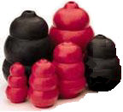 |  |  | Kong brand: black original and Ultra Kong 6", black Kongs are stronger than red ones
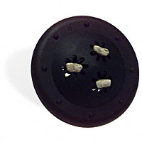 |  |  | Planet Kong "Xtreme Goodie Ship" (DO NOT place food in it)
 |  |  | GoughNuts Dog Toy - Doughnut and stick type. Green for most dogs; black for extreme chewers.
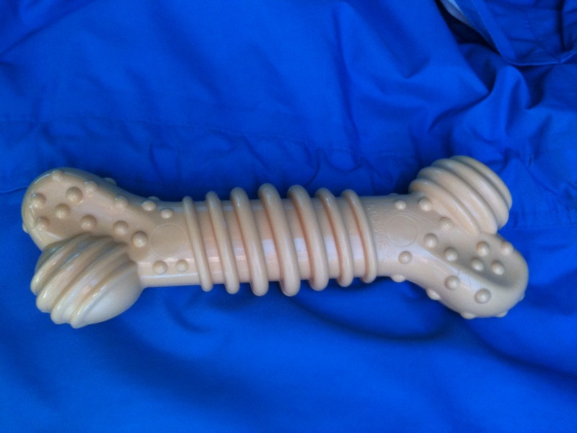 |  |  | Nylabone Dura Chew Plus  "Designed for powerful chewers, these non-edible chews have multiple textures to help clean teeth and gums. They are infused with an irresistible chicken flavor to entice your pup to chew while helping to clean teeth and control tartar and plaque build-up. Veterinarian recommended, Nylabone Dura Chew plus features multiple textures including massage nubs to provide dental stimulation."  Item Specifications:  • Regular: 4.5" long  • Wolf: 5.5" Long  • Souper: 8" Long
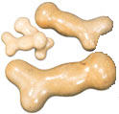 |  |  | Galileo 5" or 6" by Nylabone, also now packaged as 'Dino Bones'
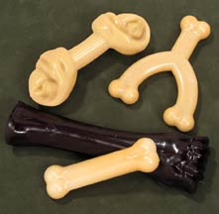 |  |  | Nylabone products: Nyla Wishbone, Nyla Ring, Nyla Knot, Dinosaur, any Nylabone (original hard material) that is appropriately robust enough for the size of puppy.
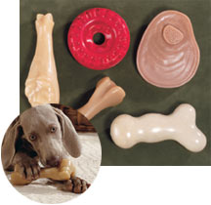 |  |  | Nyla 'Big Chews'; the red tire is OK but the yellow one is softer and not approved. Colored "keys" are not approved.
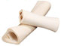 |  |  | Serilized Bones: at least 4" long (No smoked or meaty bones)
With Supervision only:
Tug toys should be put up, away from the puppy, after the game to maintain a balanced relationship.
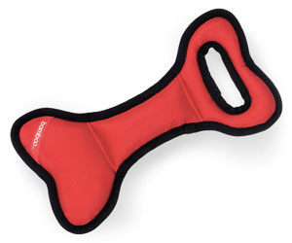 | Combat Extreme Bone Tug Toy by Bamboo Pet.
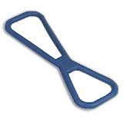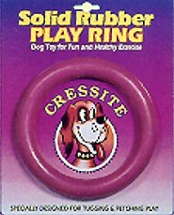 | Cressite ring and Cressite Figure 8 tug toy
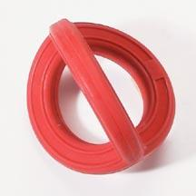 | FrameBall by Pedigree- tug toy
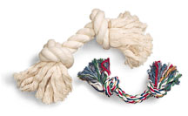 | Knotted rope toys: large, with no attachments
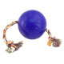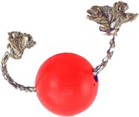 | Jollyball (no handle) with a rope through, sold as Romp-N-Roll (shown in blue).  Toss 'n' Floss is a similar large ball with rope through it, also approved (shown in red).
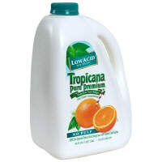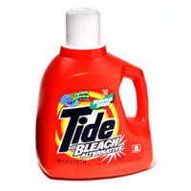 | Gallon sized or larger plastic bottles: Thoroughly rinsed, lids  labels and tops removed (orange juice or detergent bottles only)
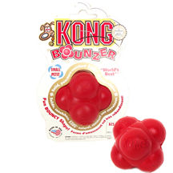 | Bounzerballs by Kong.
Restricted
for young puppies only (up to 4 months)
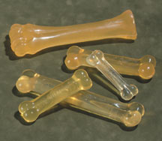 |  | Gummabone products
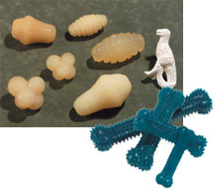 |  | Plaque Attack toys
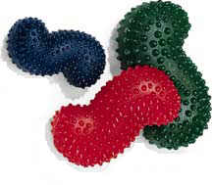 |  | Hercules bones
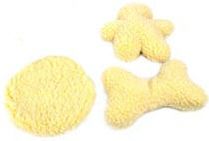 |  | Flat, white, unstuffed faux fleece toys: no squeakers
Unacceptable toys:
* Edible toys: cornstarch bones, rawhide chews/toys, pigs ears, cow hooves, edible Nylabones
* Balls
* Frisbees
* Retrieving toys
* Raw bones
* Sticks
* Personal items: socks, children's toys etc.
* Anything not on the approved list
TOY POLICY

Toys are an important part a puppy’s development. Appropriate toys provide mental stimulation, an outlet for normal chewing drive, and provide a positive alternative to destructive chewing of personal property.
A stimulating variety of toys keeps the puppy occupied. Puppies, like children, become bored with the same toys; it is highly recommended that types of toys are rotated frequently. Puppies should have a number of toys to choose from at all times; not only does this help keep the pup engaged but also reduces the chance of him ultimately becoming protective of his toys.
Not all toys currently on the market are safe for the ages, size or breeds of puppies in our program. In addition, some toys and activities are counter productive to developing a working guide. Remember, a guide must willingly work past common distractions such as balls, Frisbees or other toys encountered in everyday life.
Toys can be an effective tool in reducing attention seeking behaviors such as ‘keep away’. Puppies pick up unacceptable items and ‘parade’ them to get raisers’ attention; praising and admiring the pup that parades his toys will make him less likely to steal household items. A pup that brings his toys to the raiser is to be encouraged, but under no circumstances should raisers throw toys for a pup or participate in retrieve games.
Even the best toys experience normal wear and tear. Toys should be routinely checked for any damage, splintering or wear. Special attention should be paid to ensure the toy has not become worn to the point of becoming too small, thus posing a choking or ingesting hazard. Some dogs are voracious chewers and will destroy even the strongest, safest toys. Observe your puppy and use toys with caution with strong chewers.
In special circumstances CFRs may recommend a food stuffed Kong. Only the CFR, with supervisor approval, may recommend food in a toy. Soaked kibble, frozen in the Kong is the only allowed food.
The toys in the list below have been carefully researched by GDB staff; these are the only toys that may be accessed by a program puppy. Be sure to stay with the brand names listed below as not all toys are of good quality material.

